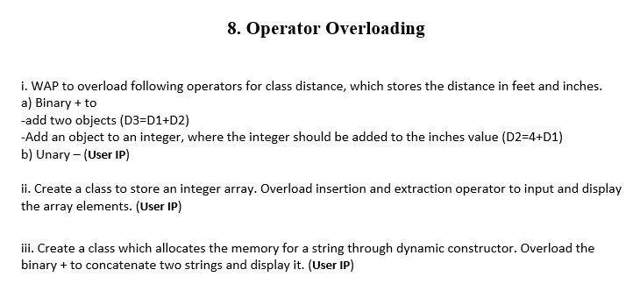**Program-1**

#include<iostream>

using namespace std;

class quest1

{

private:

int feet,inches;

public:

quest1(){

feet=0;

inches=0;

}

quest1(int feet,int inches){

this->feet=feet;

this->inches=inches;

}

quest1 operator+(quest1 const &q1){

quest1 q2;

q2.feet=feet+q1.feet;

q2.inches=inches+q1.inches;

while(q2.inches >= 12.0) {

q2.inches = q2.inches - 12.0;

++q2.feet;

}

return q2;

}

friend quest1 operator+(int z,quest1 const&q1){

quest1 q2;

q2.feet=z+q1.feet;

q2.inches=0+q1.inches;

return q2;

}

void show(){

cout<<"Distance in feet is "<<this->feet<<endl;

cout<<"Distance in inches is "<<this->inches<<endl;

}

};

class quest1b

{

private:

int x;

public:

quest1b(){

cout<<"Enter Value to be Decremented"<<endl;

cin>>x;

cout<<"Value of X before Decrementation is "<<x<<endl;

}

quest1b operator--(){

--x;

return *this;

}

void show(){

cout<<"Value of X after Decrementation is "<<x<<endl;

}

};

int main()

{

quest1 q1(23,8.6),q2(34,2.4);

quest1 q3;

q3=q1+q2;

q3.show();

quest1 q4;

q4=5+q2;

q4.show();

cout<<"Part-b"<<endl;

quest1b q1b;

--q1b;

q1b.show();

return 0;

}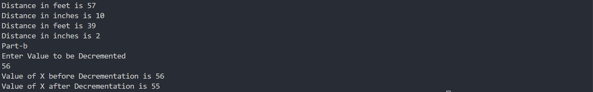

**Program-2**

#include<iostream>

using namespace std;

class quest2

{

private:

int n;

int *arr;

public:

quest2(int n);

friend istream & operator >>(istream &CIN,quest2 &q2){

cout<<"Enter Data for"<<q2.n<<" Elements"<<endl;

for (int i = 0; i < q2.n; i++)

{

CIN>>q2.arr[i];

}

}

friend ostream & operator<<(ostream &COUT,quest2 &q2){

cout<<"Below is the Elements present in the Array"<<endl;

for (int i = 0; i < q2.n; i++)

{

COUT<<q2.arr[i]<<" ";

}

}

};

quest2::quest2(int n)

{

this->n=n;

arr=new int[n];

}

int main()

{

quest2 q2(4);

cin>>q2;

cout<<q2;

return 0;

}

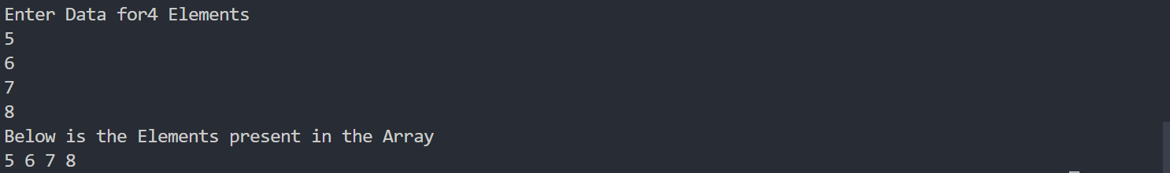

**Program-3**

#include<iostream>

using namespace std;

class quest3

{

private:

int l;

char *c;

public:

quest3(){

l=100;

c=new char[l];

}

quest3(int l){

this->l=l;

c=new char[this->l];

cout<<"Enter String"<<endl;

cin>>c;

}

quest3 operator+(quest3 &q3){

quest3 q2;

q2.l=l+q3.l;

q2.c=new char[q2.l];

int i;

for (i = 0; i < l; i++)

{

q2.c[i]=this->c[i];

}

for (int j = 0; j < q3.l; j++)

{

q2.c[i++]=q3.c[j];

}

return q2;

}

void show(){

cout<<"The Concatenated String is "<<endl;

for (int i = 0; i < l; i++)

{

cout<<c[i];

}

}

};

int main()

{

quest3 q1,q3(5),q2(6);

q1=q3+q2;

q1.show();

return 0;

}

